Bradley Trowbridge

Laboratory 4

Verilog

Step 1 Manual Truth Table

G =A'∙B'+A∙B∙D + B'∙D'+A∙C∙D

|  |  |  |  |  |  |  |  |  |  |  |  |
| --- | --- | --- | --- | --- | --- | --- | --- | --- | --- | --- | --- |
| A | B | C | D | A’ | B’ | D’ | A’B’ | ABD | B’D’ | ACD | G |
| 0 | 0 | 0 | 0 | 1 | 1 | 1 | 1 | 0 | 1 | 0 | 1 |
| 0 | 0 | 0 | 1 | 1 | 1 | 0 | 1 | 0 | 0 | 0 | 1 |
| 0 | 0 | 1 | 1 | 1 | 1 | 1 | 1 | 0 | 1 | 0 | 1 |
| 0 | 0 | 1 | 0 | 1 | 1 | 0 | 1 | 0 | 0 | 0 | 1 |
| 0 | 1 | 1 | 0 | 1 | 0 | 1 | 0 | 0 | 0 | 0 | 0 |
| 0 | 1 | 1 | 1 | 1 | 0 | 0 | 0 | 0 | 0 | 0 | 0 |
| 0 | 1 | 0 | 1 | 1 | 0 | 1 | 0 | 0 | 0 | 0 | 0 |
| 0 | 1 | 0 | 0 | 1 | 0 | 0 | 0 | 0 | 0 | 0 | 0 |
| 1 | 1 | 0 | 0 | 0 | 0 | 1 | 0 | 0 | 0 | 0 | 0 |
| 1 | 1 | 0 | 1 | 0 | 0 | 0 | 0 | 0 | 0 | 0 | 1 |
| 1 | 1 | 1 | 1 | 0 | 0 | 1 | 0 | 1 | 0 | 1 | 1 |
| 1 | 1 | 1 | 0 | 0 | 0 | 0 | 0 | 1 | 0 | 0 | 0 |
| 1 | 0 | 1 | 0 | 0 | 1 | 1 | 0 | 0 | 1 | 0 | 1 |
| 1 | 0 | 1 | 1 | 0 | 1 | 0 | 0 | 0 | 0 | 1 | 1 |
| 1 | 0 | 0 | 1 | 0 | 1 | 1 | 0 | 0 | 1 | 0 | 0 |
| 1 | 0 | 0 | 0 | 0 | 1 | 0 | 0 | 0 | 0 | 0 | 1 |

Step 2 Code Generated Truth Table

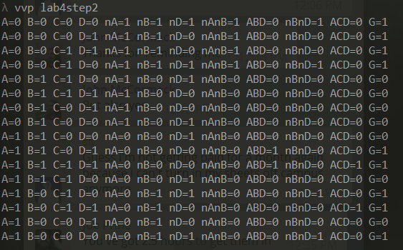

Part 3:

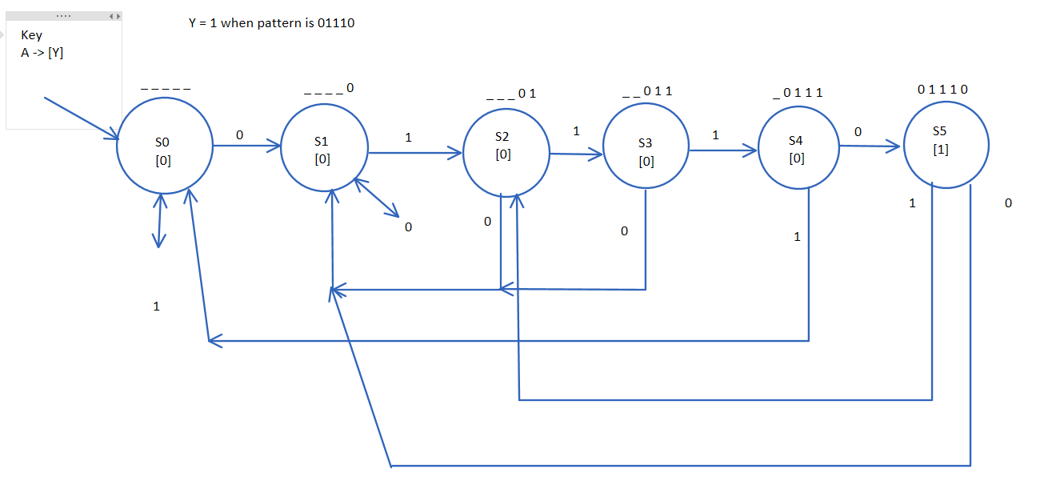

Part 4:

State Transition Table

|  |  |  |  |
| --- | --- | --- | --- |
| State | Inputs | Next State | Current Output |
| S0 | 0 | S1 | 0 |
| S0 | 1 | S0 | 0 |
| S1 | 0 | S1 | 0 |
| S1 | 1 | S2 | 0 |
| S2 | 0 | S1 | 0 |
| S2 | 1 | S3 | 0 |
| S3 | 0 | S1 | 0 |
| S3 | 1 | S4 | 0 |
| S4 | 0 | S5 | 1 |
| S4 | 1 | S0 | 0 |
| S5 | 0 | S1 | 1 |
| S5 | 1 | S2 | 1 |

Part 5: on code